* **SSgt Scott C. Bowen,** Retired Army Capt. Gary Michael "Mike" Rose, Medal of Honor recipient and father-in-law of the late Marine Corps **Staff Sergeant Scott Christian Bowen**, once said during a Gold Star Service Flag dedication, "These individuals gave up everything they had. They gave all their yesterdays and all their tomorrows so you and I can sit here and talk in relative peace and calm. That is a debt we cannot repay them. One of the things we can do is make sure their family members know that their loss is not forgotten and is remembered throughout the year. These losses are not just felt by the families, but also by friends and members of the units they served in," he continued. "Here we are in 2018 and if we forget about their sacrifices, nothing else we ever do will matter. Kaitlyn & Christian Bowen are our honored Gold Star Kids.

**No Picture Available**

**********************************************************************************

**********************************************************************************

* **Staff Sgt. Kenneth Jermaine Thomas**, member of the 1-1 Air Defense Artillery Battalion, was killed in a car accident on May 12, 2007, while serving at Kadena Air Base in Kadena, Japan. He was 25 years old, and left behind his wife, Crystal. His son Kenneth Jermaine (KJ), who is now age 18 and a student at Sparkman High, is our honored Gold Star Kid.

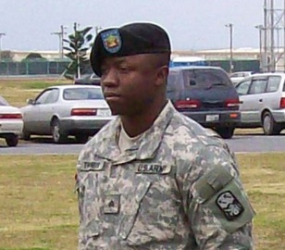

* **Chief Warrant Officer 3 Brian Woeber**, 41: After serving in the Marine Corps Reserve, Brian joined the U.S. Army in 2003 to attend flight school. He graduated Warrant Officer Candidacy School at Fort Rucker, Alabama in 2005 to become an Army aviator. Brian served his country for 14 years until his life was tragically cut short in a helicopter training exercise accident off the coast of Oahu, Hawaii. He was serving with the 2nd Battalion and the 25th Aviation Regiment. He is survived by his wife, Lori, and three sons. Two of them, Owen age 12, and Nathan, age 15, will are our honored Gold Star Kids laptop recipients.

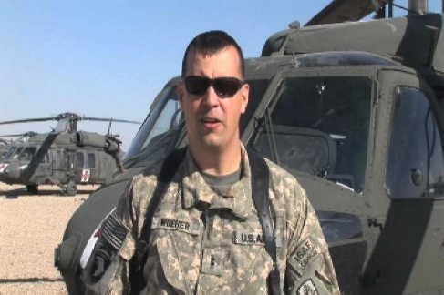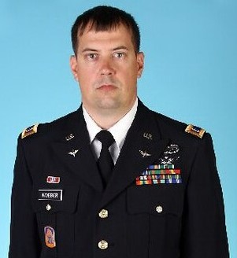

* **SPC Ryan Winkelmann,** father of Gold Star Kid Kinsey Tuttle, passed away suddenly in early January 2013 due to a medical condition. Ryan Winkelmann was a decorated infantryman and a first sergeant in the U.S. Army. Winkelmann served with the Honor Guard at Arlington National Cemetery, Va. for 1.5 years. Winkelmann’s military honors include the Combat Infantryman’s Badge, Good Conduct Medal, Expert Rifleman’s Ribbon, Service Medal, National Defense Ribbon and two Overseas Ribbons for tours in Iraq. He lived honorably and served as an inspiration to all who knew him.

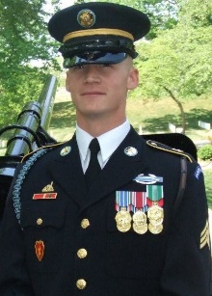 

* **Lt. Col. Alonzo B. McGhee,** 44, a logistics management specialist assigned to the ACC Operations Group, died Jan. 4. A native Georgian and graduate of Georgia Southern University, Troy University and Central Michigan University, McGhee served his nation faithfully for more than 22 years. His daughter Aleena is the recipient of a Gold Star Kid Laptop to help her further her education.

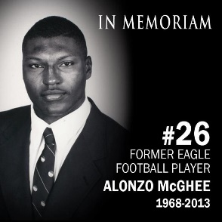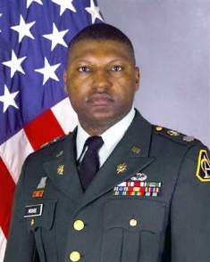

* **Chief Warrant Officer 2 (CW2) Edward Goodloe** entered the U.S. Army-HHC in November 1994. Goodloe attended Basic Combat Training at Fort Jackson, S.C. He worked as MOS: 915A – Unit Maintenance Technician. Goodloe also was stationed at Fort Benning, Ga. He was commissioned as warrant officer at Fort Rucker in July 2005. Goodloe served in the Community-Based Warrior in Transition Unit – Alabama. He attached to G4 (Transportation) and U.S. Army Space and Missile Defense Command/Army Forces Strategic Command in Huntsville. On Feb. 5, 2011, Goodloe was in active duty in Huntsville when he died of cancer at 42 years old. Brianna age 17, and Edward age 14, are two of his children and two of our honored Gold Star Kids.

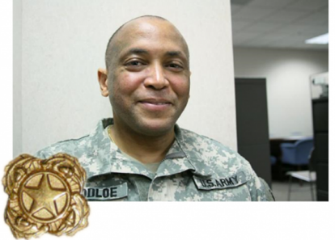



* **Staff Sergeant Yance Tell Gray,** age 26, Raeford, NC, formerly of Ismay, MT, was killed in action on September 10, 2007, while serving with the United States Army, stationed in Iraq He was a member of Charlie Troop (1/73 Cav) 1st Battalion, 325 Airborne Infantry Regiment, 82nd Airborne Division. Tell proudly entered the US Army in June 2000. He had completed three active tours of duty, in both Iraq and Afghanistan, his fourth to be completed in November of 2007. Tell was introduced to his future wife Jessica Duncan while at home on leave. After a courtship extending two combat tours, Tell and Jessica were married on August 6, 2004. Tell and Jessica had their first baby Ava Madison Gray on April 3rd 2007. Tell was unable to be there but sat on speakerphone from Iraq the entire time cheering Jessica on. Ava is now 13 years old and one of our honored Gold Star Kids.

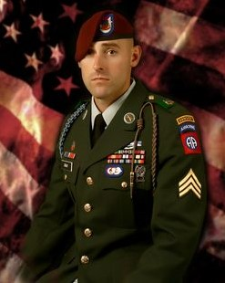

* An army medic, **Charles D. Parrish** trained many of the medics who assisted in his surgery after his own fatal attack, his mother said. "They said he gave a good fight," said Tina Rigsby. SPC Parrish, 23, of Jasper, Ala., died June 4 while attacked during a reconnaissance mission to clear land mines in Jalula. He was assigned to Fort Leonard Wood. Col. Rob Risberg said Parrish "was a very popular soldier," adding that about 200 of his comrades lined up outside the hospital prepared to give blood while he was undergoing surgery. His son Caden is our honored Gold Star Kid.

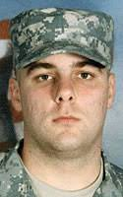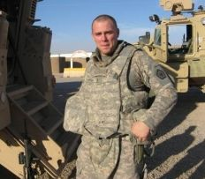

* **Sgt. Jason Stegall**, an Alabama soldier honored for his heroics in battle, passed away on December 14, 2009, at age 31 from complications of H1N1virus. During his five-year military career, he was stationed at Ft. Richardson, Alaska with the 501st "GERONIMO" as a paratrooper which he loved dearly. He was deployed with this unit for 15 months during Operation Iraqi Freedom where he earned a Bronze Star with "V" device for Valor and a Purple Heart. Other awards and decorations he was awarded are Meritorious Service Medal, two Army Commendation Medals, two Army Achievement Medals and the prestigious Combat Infantry Badge. He also has a second Purple Heart pending approval for his actions while in Iraq. His now 11-year- old son Landon is our Gold Star Kid honoree.

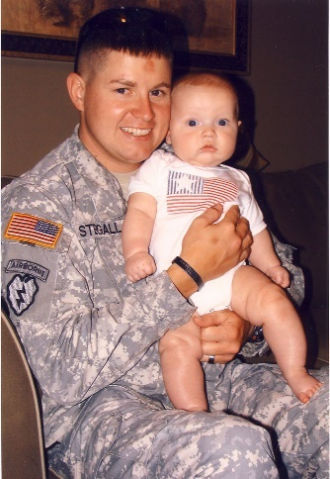

* **SSG Thomas Michael McFall,** 36, was killed by a roadside bomb May 28, 2007 while on foot patrol in Baghdad**.** An abiding sense of duty led Army Staff Sgt. Thomas McFall to ignore a back injury and accompany the troops he’d been training to Iraq. He had been stationed at Ft. Lewis, Wash., since 1998. In January, 2007, he was assigned to the 1st Battalion, 38th Infantry Regiment as a staff sergeant, where he trained a group of soldiers to go to Iraq. McFall served as a father figure to many of the younger men he served with. McFall's family was presented with his medals: the Bronze Star Medal for meritorious service; Purple Heart for combat wounds; Army Commendation Medal for act of heroism; Expeditionary Service Medal; Global War on Terrorism Service Medal; and Iraq Campaign Medal. Matthew McFall, 16 years of age, is our Gold Star Honoree.



* **Capt. Waid "Chip" Ramsey**, 41, of Red Bay, Alabama, died August 4, 2011 in Paktika Province, Afghanistan. Ramsey was assigned as the Commander of Headquarters and Headquarters Company, 20th Special Forces Group (Airborne). Ramsey assumed command of the HHC on 1 October 2005. Prior to that assignment, he was the Commander of the Headquarters and Headquarters Detachment, 1st Battalion, 20th Special Forces Group (Airborne). Ramsey’s Military Decorations include the Bronze Star Medal, the Good Conduct Medal, the Global War on Terrorism Service Medal, the US Army Parachutist Badge, the Air Assault Badge, the Army Reserve Components Achievement Medal, and the Faithful Service Medal for Alabama. Cap’t Ramsey’s son, Bradley age 16, and his daughter, Megan age 14, are our honored Gold Star Kids laptop recipients.



* **Sgt. First Class Christopher D. Henderson,** 35, was killed during Operation Enduring Freedom. He died on June 17, 2007, in Panjway, Afghanistan of wounds suffered when an improvised explosive device detonated near his vehicle. Chris never met a stranger. He was always willing to help others. He tried to make the world a better place. Chris' answer for deployments was to hopefully make other places better for both his daughter, Kayley and future generations in other countries. Chris is remembered as being a man of great creativity, perspective and humor. His daughter Kayley is our Gold Star Kids honoree. She is now 21 years old and will be presented with a laptop to assist in her future endeavors.

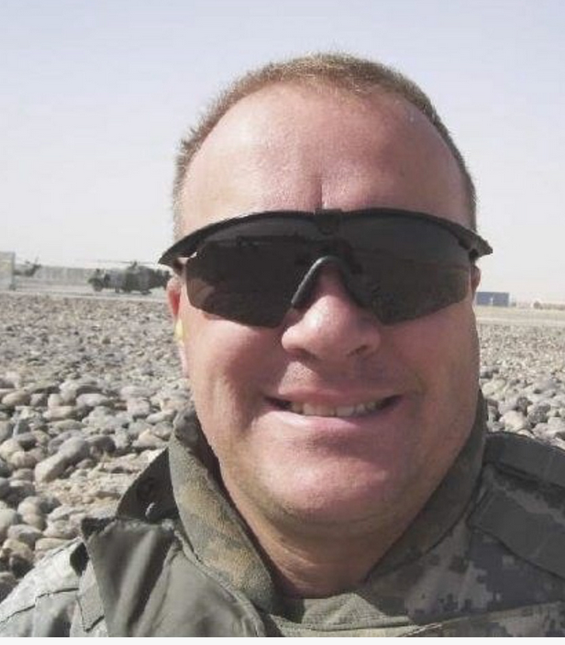

* **Army Spc. Kyle A. Little**, 20, was killed by a roadside bomb May 8 north of Baghdad during his second tour in Iraq. Little dropped out of high school, feeling it wasn’t the place for him, and joined the Army at age 17, a few months before he would have graduated, his mother, Shelly Smith, told the Telegram & Gazette of Worcester. Little seemed to mature in the service, which he intended to make his career, his father said. He was working as a bodyguard during his second tour, Michael Little said. “He was there because he wanted to be there, and he did what he liked to do,” he said. Kyle Little was the oldest of five brothers and sisters. His wife, Tiffany, was three months pregnant with their daughter, Kylee, when Kyle was killed. Kylee, now 13 years old, is our Gold Star Kids honoree.

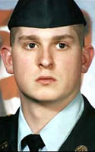

* **Sgt. Sylvester Cline,** an Iraq combat veteran, died at age 32 during training at Fort Chaffee in Arkansas from a heatstroke  after 9 hours of a training exercises on a sweltering day in June 2016. Cline was a father of 5 and was known as “Mr. Mom” for his devotion to his children.

Cline enlisted in the Arkansas National Guard in 2002 and participated in a combat deployment to Iraq with the 39th Infantry Brigade in 2008. He was awarded the Iraq Campaign Medal and the Global War on Terrorism Service Medal, among other awards and decorations, according to the Guard. Sgt. Cline’s daughter Za’Niya, age 15, is our honored Gold Star Kid.

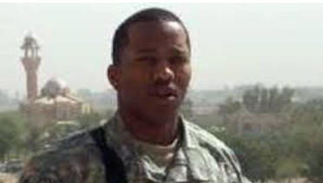 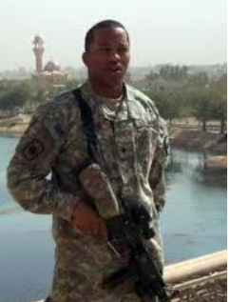

* **Army Staff Sgt. Joshua Bowden** died at age 28 in Ghazni, Afghanistan while serving during Operation Enduring Freedom of injuries sustained when enemy forces attacked his unit with small arms fire.  SSG Bowden joined the Army in 2005.  He was on his second deployment to Afghanistan, having been previously deployed in 2008, when he died on August 31, 2013. His most recent assignment was to the 71st Ordnance Group, 242d Ordnance Battalion, 748th Ordnance Company, at Fort Carson, CO.  His awards include the Joint Service Commendation Medal with Valor, Purple Heart, Joint Defense Meritorious Service Medal, NATO Medal, Combat Action Badge, Senior Explosive Ordnance Disposal Badge, Parachutist Badge, and the Air Assault Badge. Sgt. Bowden’s son, Kaden, age 12, is our honored Gold Star Kid.

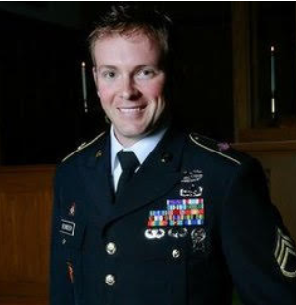

* **SPC Cole Chaney** of the US Army, died at age 22 and loved his family, God, and country above everything. Cole Chaney, one of happiest people I ever met," says his wife, was transferring the family from Fort Sill in his home state of Oklahoma to Fort Lee, Va., when his moving van was involved in a wreck. He was killed and a most of the family possessions were destroyed, including photos, paperwork and furniture. KayCee has no memory of his late father. Spc. Cole Chaney - the KayCee comes from his parents' initials - died Aug. 5, 2008. KayCee's first birthday was eight days later.  He is the spitting image of his father, the same eyes, same smile, "his Daddy made over," Krystal says. KayCee, 13 years of age, is our Gold Star Kid honoree.

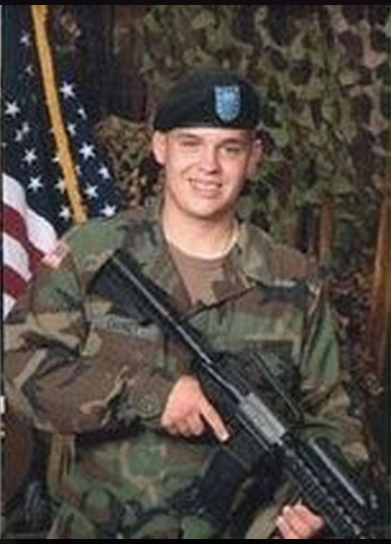

* **Lance Corporal Cody A. Roberts** joined the U.S. Marines in 2006. He was on his first deployment to Afghanistan when he was killed on August 31, 2010. He died as a result of combat operations in Helmand province of southwest Afghanistan while supporting Operation Enduring Freedom. He was 22 years old. Lance Corporal Roberts was a rifleman in the 2nd Battalion, 6th Marine Regiment, Regimental Combat Team 7, I Marine Expeditionary Force Forward. He was awarded the National Defense Service Medal, Afghanistan Campaign Medal, Global War on Terroirsm Service Medal, and the Global War on Terrorism Expeditionary Medal. Cody’s son Colten, age 10, is our Gold Medal Kids Honoree.



* **Staff Sgt. Dennis Springer** died on July 12, 2008, at the age of 26. He is survived by his wife April, and sons Caleb and Avery. Avery is now 16 years old and our honored Gold Star Kid.
* **Army Sgt. Christopher R. Bell** died June 4, 2011, age 21, while serving during Operation Enduring Freedom. He was assigned to 793rd Military Police Battalion, 3rd Maneuver Enhancement Brigade, Joint Base Elmendorf-Richardson, Alaska and died of wounds suffered June 4, in Alingar, Laghman province, Afghanistan, when insurgents attacked his unit with an improvised explosive device. He is survived by his wife Samantha Lucas Bell and daughter Lana Nicole Bell, age 11, our Gold Star Kid Honoree.

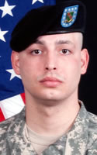

* **Army Spc. Shawn A. Muhr** died on January 29, 2011 when his military truck was struck by a roadside bomb in Helmand Province, Afghanistan. He was serving during Operation Enduring Freedom, and was 26 years of age. Spc. Muhr was assigned to the 264th Combat Sustainment Support Battalion, 82nd Sustainment Brigade, Fort Bragg, N.C. Muhr joined the Army six years ago after working for about a year at a Council Bluffs meatpacking plant. He was a truck driver in a military transportation unit and was on a mission with a convoy of Army trucks when he was killed, family members said. Muhr was married to Wendy Olchawa and has a stepchild, Devin, age 10, our Gold Star Kids Honoree.

